CARLTON THEATRE GROUP - CYRANO DE BERGERAC AUDITION FORM

Email:

Phone number:

Parts auditioning for

Parts you do not want to be considered for, if any:

Previous acting experience

Additional Skills:

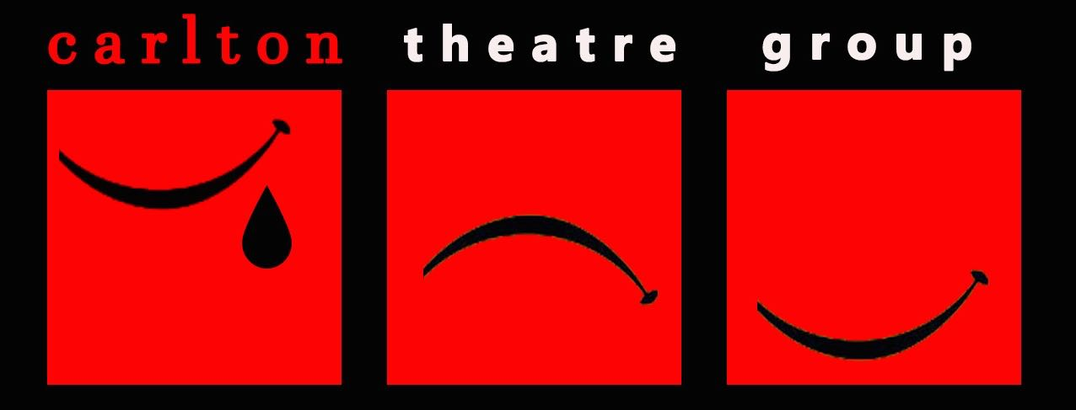
This production is not a musical, but there are elements of movement, singing and dancing for some roles. The most important factor is a willingness to have a go, but it would be useful to get some indication of experience and ability in the following areas. Please rate yourself from 1-10 for each of the below (e.g. 1 = tone deaf/two left feet; 5 = adequate/could be part of a group; 10 = happy to sing and dance solo).

Singing:

Dancing:

General movement:

AVAILABILITY CHECK:

Rehearsals will take place on Tuesday and Thursday evenings, starting Tuesday 26th May. Please list any dates you are unable to attend rehearsals from Tuesday 26th May - Thursday 6th August:

Are you also available for any additional Sunday rehearsals on the following dates?

5th July [YES/NO]
12th July [YES/NO]
19th July [YES/NO]
2nd August [YES/NO]

All cast MUST be available 11:30-18:00 on Sunday 9th August for get in and tech, 18:00–22:00 on Monday 10th August for dress rehearsal, 18:00-23:00 on Tuesday 11th August - Friday 14th August for evening performances, and 13:15-23:00 on Saturday 15th August for a matinee and evening performance.

CARLTON MEMBERSHIP:
Although you do not have to pay to audition, Carlton is an amateur dramatic society and requires those appearing in productions to be members and pay a production fee. Membership is £40 per annum. Production fees are £50 for a Major role, £25 for a Medium role and £10 for a Minor role. Please type YES after this statement to indicate you understand.

GDPR DISCLAIMER:

Please type YES after each statement that applies to you.

I understand that if cast I must become a member of Carlton Theatre Group. By becoming a member, I consent to the contact information I have provided being passed on to, and to receive communication from, the Carlton committee, the director and crew of the production of Cyrano de Bergerac and to be added to the membership mailing list.

If cast, I agree to participate in any marketing and publicity necessary to help promote the production. I understand that my image/voice/name will be recorded and consent to this material being edited and used for print and digital marketing.

I would like to sign up to the Carlton general mailing list to be informed of future auditions, productions and events. Current members of Carlton can ignore this.

Signed

Date

