CARLTON THEATRE GROUP - AN ENEMY OF THE PEOPLE AUDITION FORM

(please print clearly)

Email:

Phone number:

Parts auditioning for

If I am unsuccessful in obtaining a part or parts for which I have auditioned, I am willing to accept any part for which I am cast. [YES/NO]

Previous acting experience

AVAILABILITY CHECK:
Rehearsals will take place on Tuesday and Thursday evenings, starting Tuesday 24th February. Please list any dates you are unable to attend rehearsals from Tuesday 24th February – Thursday 7th May:

All cast MUST be available 11:30-18:00 on Sunday 10th May for get in and tech, 18.00–22.00 on Monday 11th May for dress rehearsal, 18:30-23:00 on Tuesday 12th - Friday 15th May for evening performances, and 13:45-23:00 on Saturday 16th May for a matinee and evening performance.

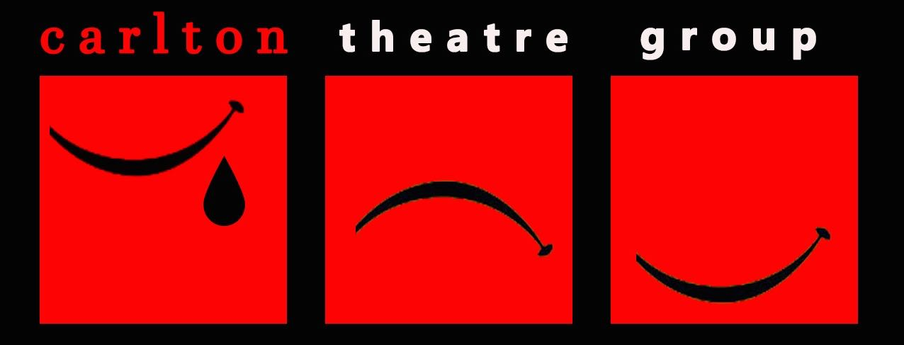

CARLTON MEMBERSHIP:
Although you do not have to pay to audition, Carlton is an amateur dramatic society and requires those appearing in productions to be members and pay a production fee. Membership is £40 per annum. Production fees are £50 for a Major role, £25 for a Medium role and £10 for a Minor role. Please type YES after this statement to indicate you understand.

GDPR DISCLAIMER:

Please type YES after each statement that applies to you.

I understand that if cast I must became a member of Carlton Theatre Group. By becoming a member, I consent to the contact information I have provided being passed on to, and to receive communication from, the Carlton committee, the director and crew of the production of An Enemy of the People and to be added to the membership mailing list.

If cast, I agree to participate in any marketing and publicity necessary to help promote the production. I understand that my image/ voice/ name will be recorded and consent to this material being edited and used for print and digital marketing.

I would like to sign up to the Carlton general mailing list to be informed of future auditions, productions and events. Current members of Carlton can ignore this.

Date

